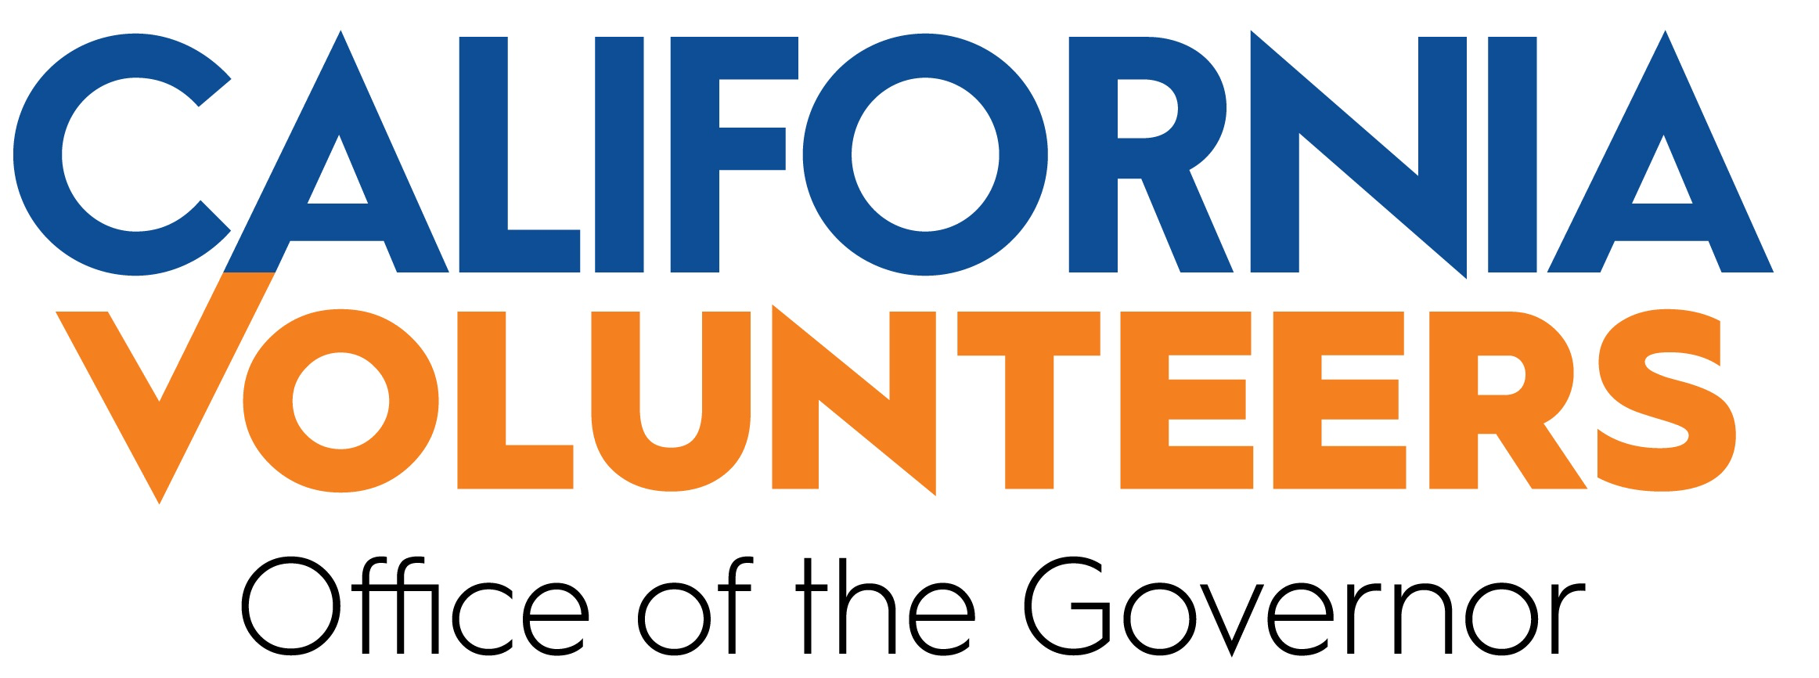

POSITION DESCRIPTION: GRANT COMPLIANCE MANAGER
(Salary is commensurate based on experience)

About California Volunteers:
California Volunteers (CV) is the State Service Commission, tasked with engaging Californians in creative and innovative service and volunteer strategies in order to solve pressing challenges facing our communities. Within the Governor’s Office, California Volunteers is uniquely positioned to develop and launch projects and initiatives to support the Governor’s service and volunteer priorities, building the state infrastructure to ensure all Californians can lead and creating a robust culture of service statewide. From the California Climate Action program, the country’s first statewide climate corps program, to the #CaliforniansForAll initiative focused on leveraging our greatest assets, all Californians, in volunteerism, California Volunteers’ collective impact model ensures all programs and investments are targeted and focused on creating the greatest impact for all Californians.
Led by the state’s Chief Service Officer, Josh Fryday, California Volunteers is supported by a bipartisan 25-member Commission and a team of experts driven by a mission to empower and mobilize all Californians to volunteer and serve in their communities.
Position Description:
The Grant Compliance Manager, under the direction of the Operations Director, will serve as the lead for grant compliance at California Volunteers. In addition to providing periodic audits of grant programs, terms and conditions, and training to staff on compliance measures and processes, the Grant Compliance Manager will also draft reports to the California Volunteers’ Executive Team on grant compliance related issues and opportunities for growth and improvement within organizational operations. Additionally, the Grant Compliance Manager will support procurement-related activities, when needed.
Duties:
55% Grant Planning and Oversight
- Review grant applications to ensure alignment with federal grant requirements, specifically terms and conditions, Office of Management and Budget Super Circular, etc.
- Plan and assign tasks pertaining to contracts and grants.
- Review requests for proposals and applications to ensure alignment with federal and state procurement policies and procedures, terms and conditions, etc.
- Provide support to staff developing procurement documents.
- Provide training to staff on grant compliance processes and workflows to ensure effective grant management.
40% Oversight of Contract/Grant Management
- Provide periodic audits and “desk reviews” of contractor/grantee invoices and reports.
- Manage any federal Improper Payments Elimination and Recovery Improvement Act requests associated with AmeriCorps programs, including coordinating with programs to ensure timely submission of requested documents, etc.
- Draft grant compliance reports for California Volunteers’ Executive team, showing areas and opportunities for improvement of administrative and programmatic functions.
- Assist staff in supporting contractor/grantee compliance with federal and state regulations.
5% Other Duties as Assigned
Qualifications:
- Bachelor’s degree in accounting or related field of study.
- Federal grants management experience strongly encouraged.
- General understanding of budgetary processes, finance, auditing, and accounting is strongly encouraged.
- At least 1-2 years of experience with program evaluation and grant compliance monitoring is a plus, though not required.
- Excellent attention to detail.
- General understanding of federal and state government.
- Strong written and verbal skills.
Desired Qualifications
- Bilingual in English and one of California’s most spoken languages (Spanish, Chinese, Tagalog, Vietnamese, and Korean) a plus.
- Proven commitment to creating a work environment that celebrates diverse backgrounds, cultures, and personal experiences.

